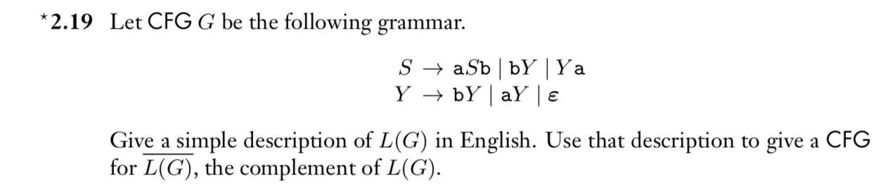

Description L(G)
- Consecutive numbers of a’s from 1 to ∞
- Consecutive numbers of b’s from 1 to ∞
- Start with a then n number of b’s
- Start with a then ends with b
- Start with b then n number of a’s
- Start with b then ends with a

S -> aSb | ∈

